HOMEWORK

1. Draw the shape corresponding to the Boolean expression

a, (x > 2 and x < 4) or (y < 2) 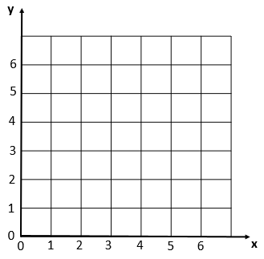

b, (x>2 and x<6) and (y>2 and y<6) and not(x>4)



2, Write the boolean condition for this grid

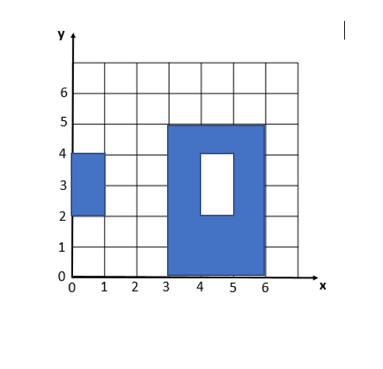

Expression:

((x>0 and x<1) and (y>2 and y<4))

Or ((x>3 and x<6) and (y>o and y<5) and

Not(x>4 and x<5) and (y>2 and Y<4))

2. Demonstrate these equalities using the 9 simplification rules you have learnt:

* !(C and D) and (!C or D) and (C or !D) = !C

!(C and D) and (!C or D) and (C or !D) = (!C or !D) and (!C or D) and (C or !D)

=!C or (!D and D) and (C or !D)

=!C or (false and (C or !D))

=!C or ((false and C) or (false and !D))

=!C or (false or false)

=!C or false

=!C

* ! ( !C and (!B or !C) ) = C

=!(!C and !(B and C))

=(C or (B and C))

=C and (B and True)

=C and true

=C

* (A and B) or (A and !B) = A

= A and (B or !B)

=A and true

=A

3.. What is the output of flowchart? If x=6 and y = 5 and z = 1

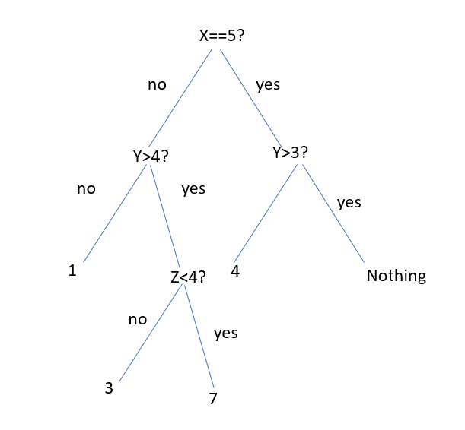

The output of this flowchart is 7

1. Draw the tree of conditions

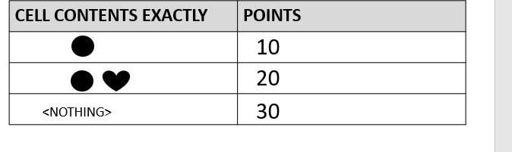

Yes

No

30

Yes

No

20

10

1. Draw the tree of conditions

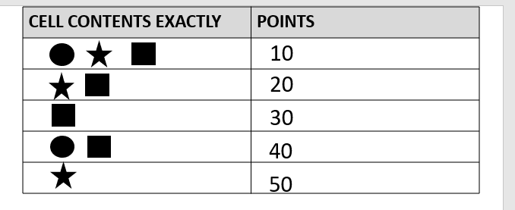

No

Yes

No

Yes

No

Yes

No

No

Yes

Yes

Yes

No

Yes

0

0

40

10

50

30

20

1. Draw the tree of conditions

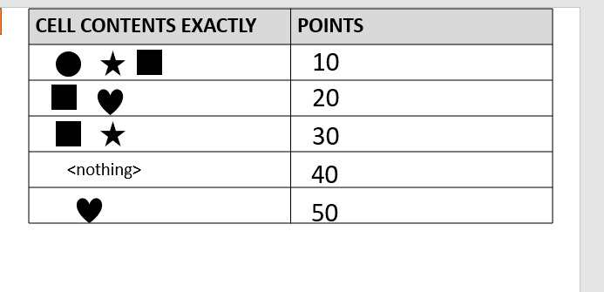

No

Yes

No

Yes

No

Yes



0

No

40

Yes

No

Yes

No

Yes

50

0

30

10



No

Yes

20

0

7.

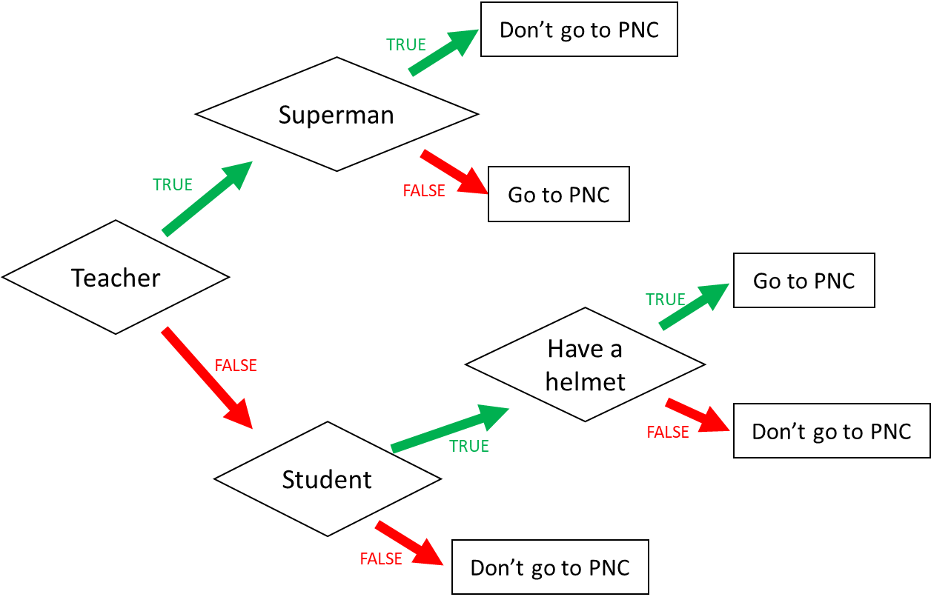

1. I am a teacher and I am superman, can I go to PNC?

**Don’t go to PNC**

1. I am not a teacher and not a student, can I go to PNC?

**Don’t go to PNC**

1. When can I go to PNC? (Express the condition using a Boolean expression)

I go to PNC if: I am a teacher and not superman or I am not a teacher and I am a student and I have a helmet

8

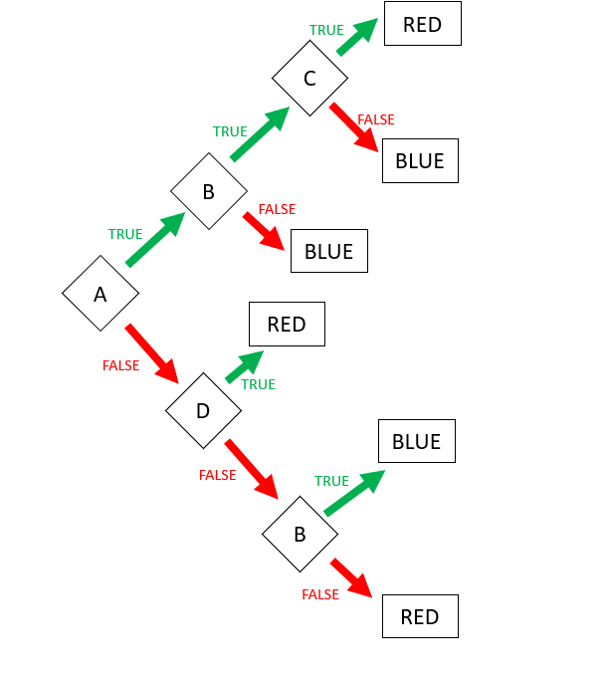

Expression: **RED** = …ABC or !AD or !A!D!B …………………………………………………………………………………………..

Expression: **BLUE** (FALSE) = …A!B or AB!C ……………………………………………………………….

9. Encoding

* First 3 characters “MIX”, repeated many times (max repetition is 5)
* Then 1 character “!”, repeated many times (max repetition is 5)
* Then 1 number (0-3)

Examples:

MIXMIXMIX!1

MIX!!!!!3

MIXMIXMIX!!!2

**Q1**. Propose an **encoding** **structure** to encode this image.

|  |  |
| --- | --- |
| Encoding parts | Encoding values (in binary) |
| The repetition of text “MIX”: 1…5 | 001…101 |
| The repetition of character “!”: 1…5 | 001…101 |
| The number of the end: 0..3 | 00…11 |
|  |  |

**Q2**. What is the total **size** of your encoding? Give explanations.

Encoding size:8bits

*Explanation:*

Part1: 101 that mean text of MIX repeated 5 times

Part2: 101 that mean character if ! reqpeated 5 times  
Part3: 11 that mean the number at the end is 3.

We want to encode **a text** following those rules:

* 3 letters: A, B, C
* The letters are always in the alphabetic order
* Letters are repeated from 1 to 10 times
  + Each letter is repeated the same number of times
* The last character must be either: X, Y, or Z

*Examples:*

|  |  |
| --- | --- |
| ABCZ | Good |
| AAAABBBBCCCCX | Good |
| AABBCCY | Good |
| AAABBBCCCX | Good |
| AABBBBCCX | Bad: letter A is repeated 2 times but letter B 3 times |

**Q1**. Propose an **encoding** **structure** to encode this image. (20pts)

|  |  |
| --- | --- |
| Encoding parts | Encoding values (in binary) |
| The repeatation of letters “A”,”B”,”C”: 1....10 | 0001....1010 |
| The last characters : X : 0  Y : 1  Z : 2 | 00  01  10 |
|  |  |
|  |  |

**Q2**. What is the total **size** of your encoding? Give explanations.

Encoding size:(4pts)

Total encoding size is :6 bits

*Explanation:(6pts)*

* Part 1 : 1010 that mean letters “A” and “B” and “C” repeated 10 time
* Part 2 : 00 is letter X, 01 is letter Y, 10 is letter Z